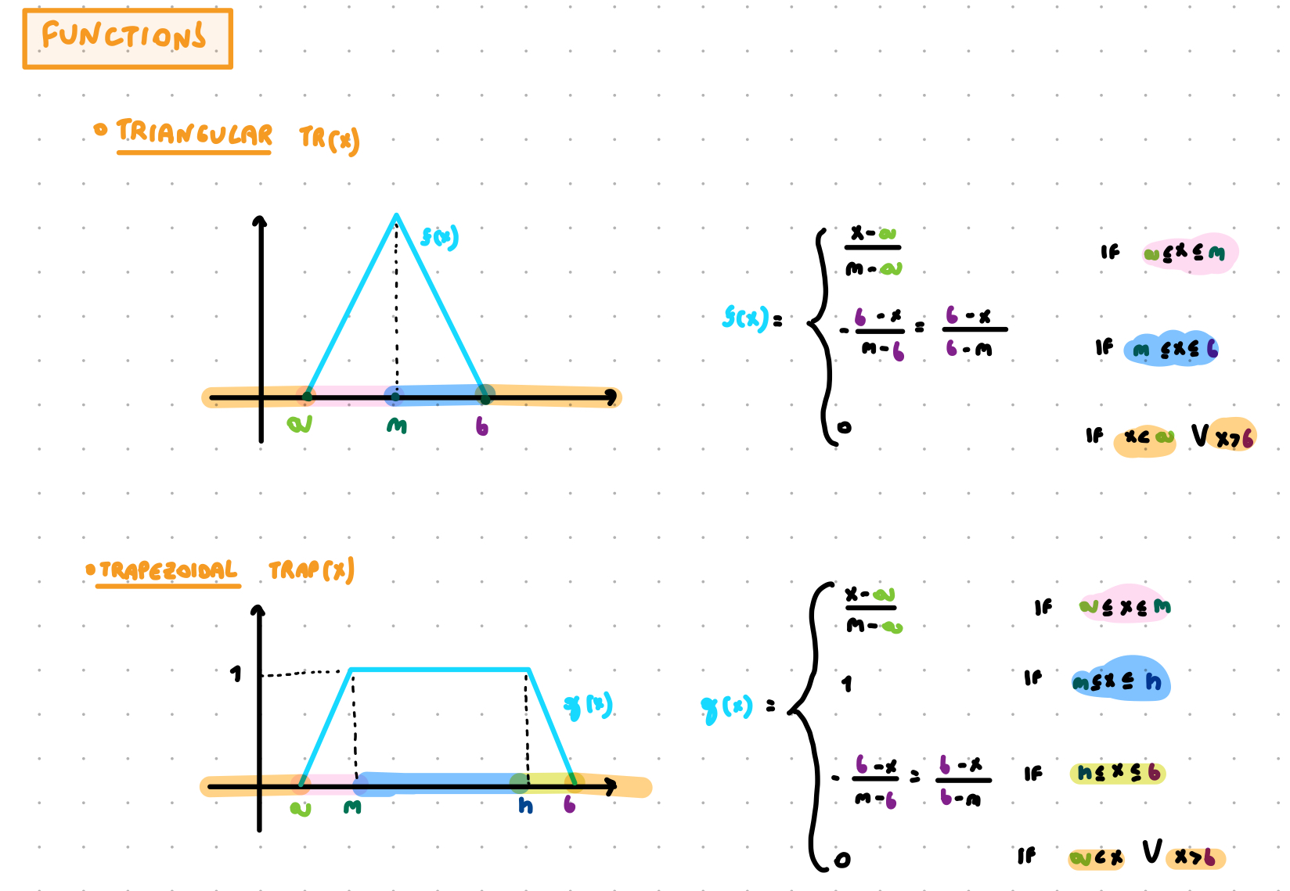

Normal: if $sup(f(x)) = 1$

Support: if $\{x ϵ X | f(x) > 0 \}$

Core: if $\{x ϵ X | f(x) = 1 \}$

α-cut: if $\{x ϵ X | f(x) ≥ α\}$

Strong α-cut: if $\{x ϵ X | f(x) > α\}$

Cardinality: sum of the membership degree

Entropy: $sum[mu(x) ×log(\frac{1}{mu(x)}) ]$ where $mu(x)$is the membership degree of x. alternatively you can use $-sum[mu(x) × log(mu(x))]$

Fuzzyness with Hamming distance: sum(mu(x) - (1-mu(x) ) / supp(g) ) that is equal to sum[2mu(x) - 1] / supp(g)

Sample 1

Exercise 1

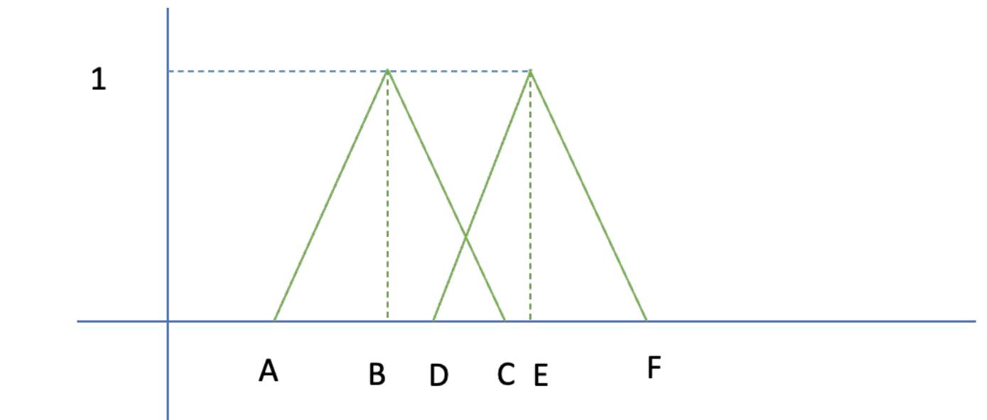
- Let us consider the two fuzzy sets f and g defined in the following figure by the points ABC and DEF with A=1, B=3, C=5, D=4,E=6,F=8.
  - Give the equation of the functions f and g
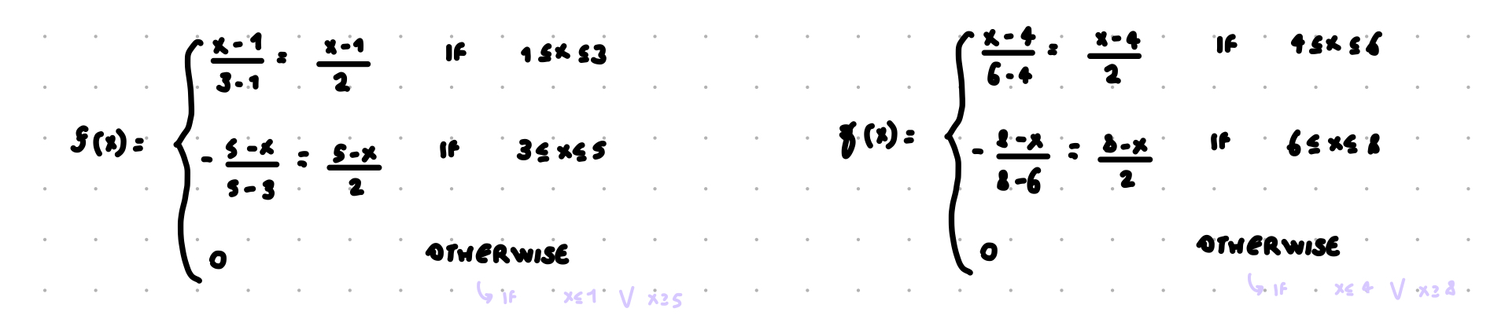
  - Compute the intersection and union of f and g by means of t-norm/t-conorm of your choice
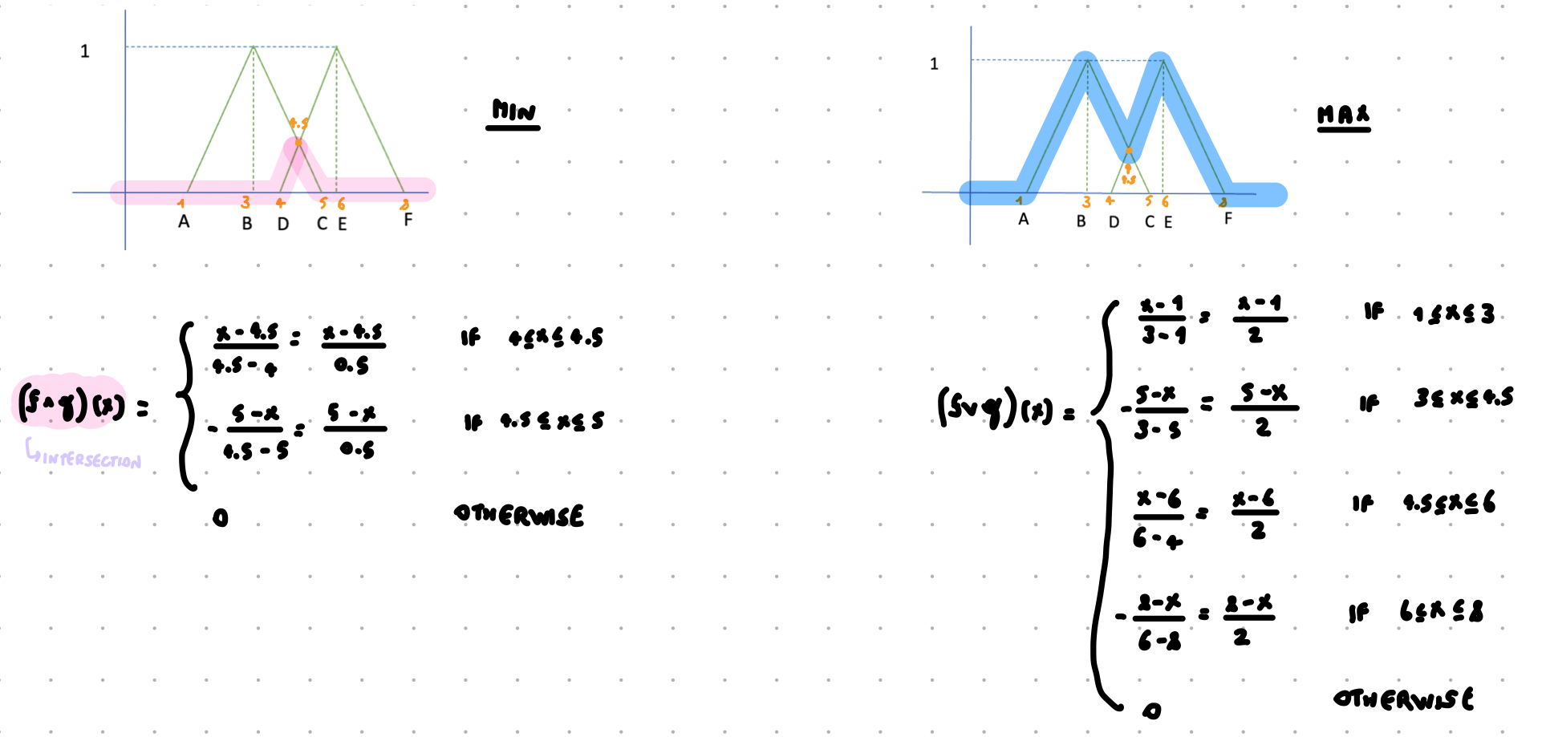
  - Compute the complement of f and g
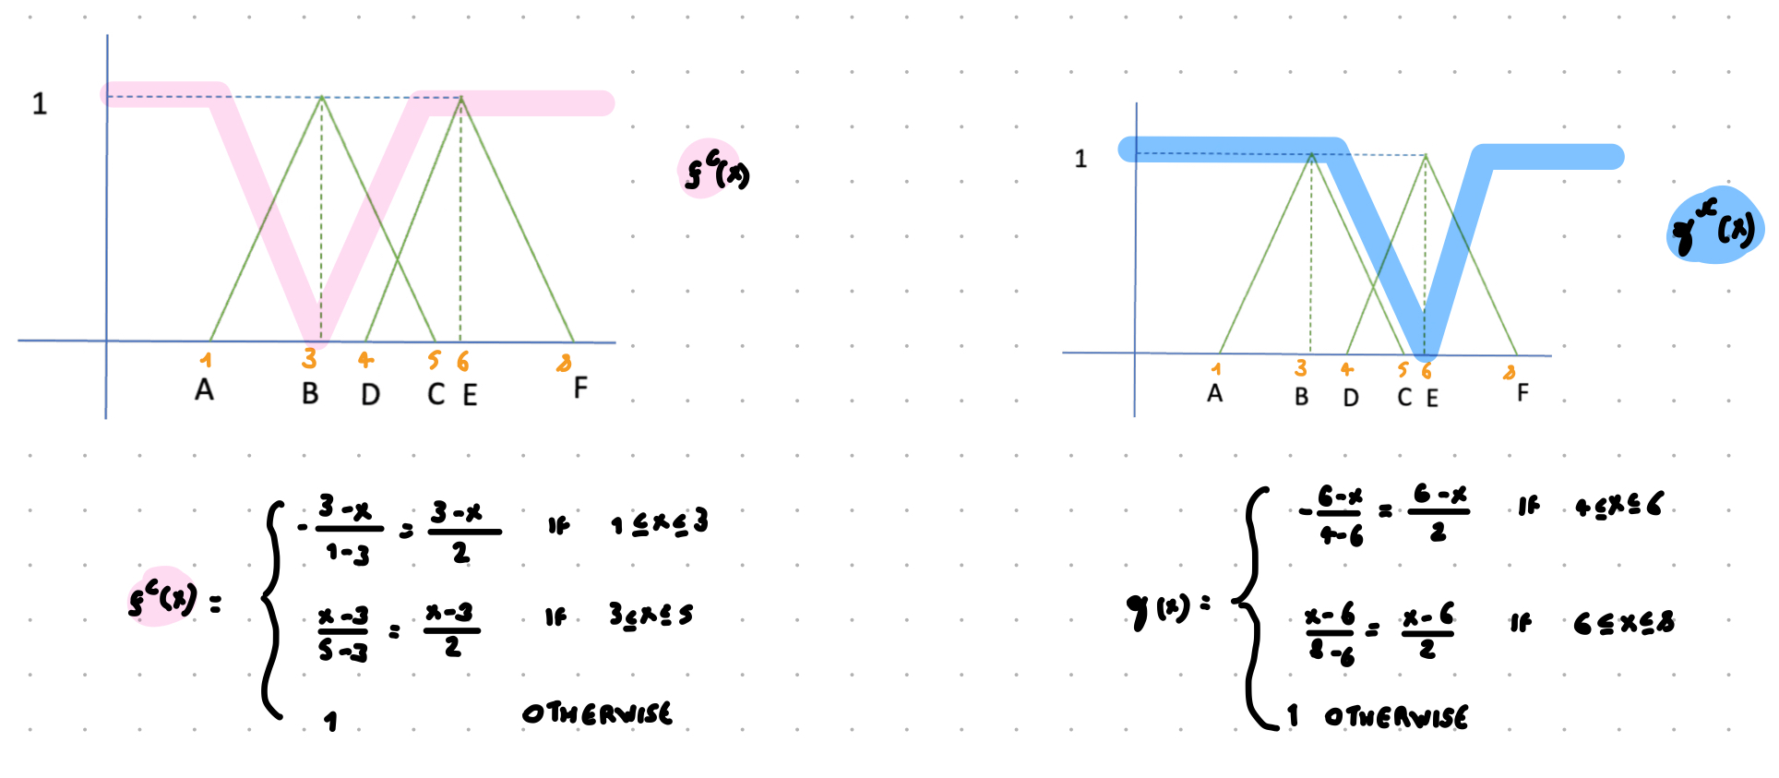
  - Compute support and core of f and g
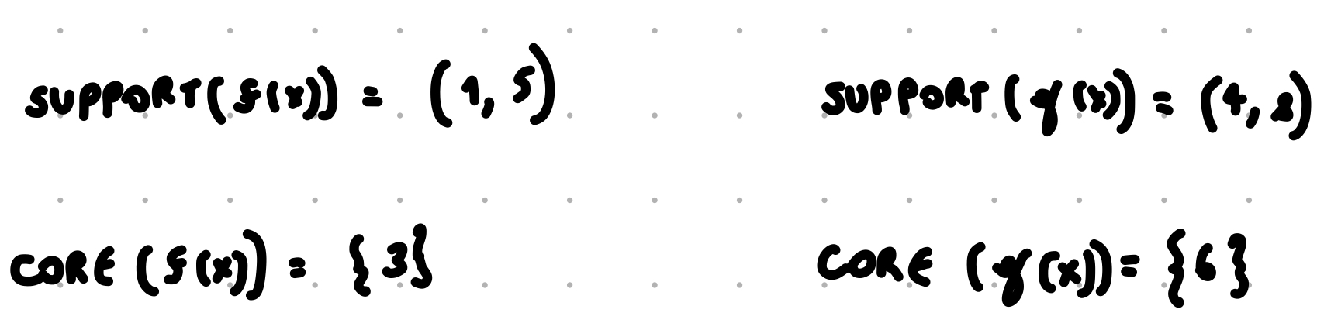

- Let us consider the fuzzy set g defined as g(10)=0.3, g(15)=0.5, g(20)=1, g(25)=1, g(30)=0.5, g(35)=0.3, g(x) = 0 for all other values of x.
  - Compute core and support of g
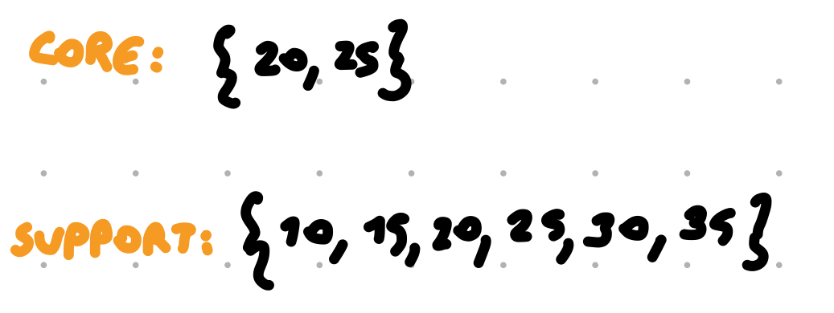
  - Compute the complement of g
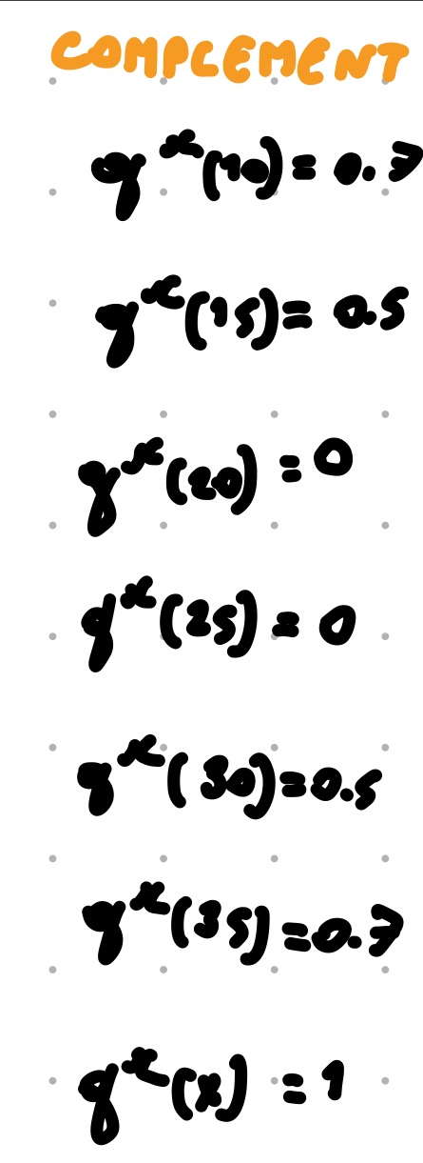
  - Compute the cardinality g
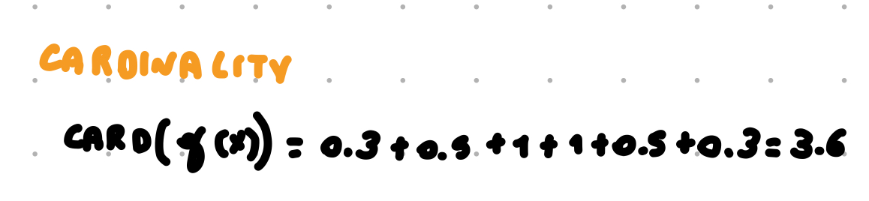
  - Compute the α cut of g with α=0.4
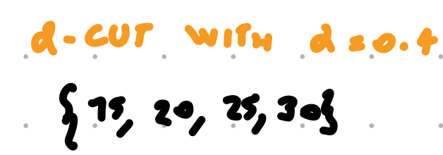
  - Compute the entropy of g
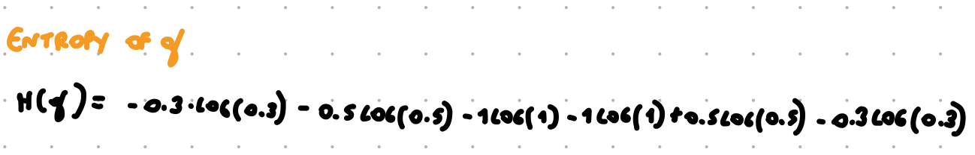
  - Compute the measure of fuzziness of g using the Hamming distance
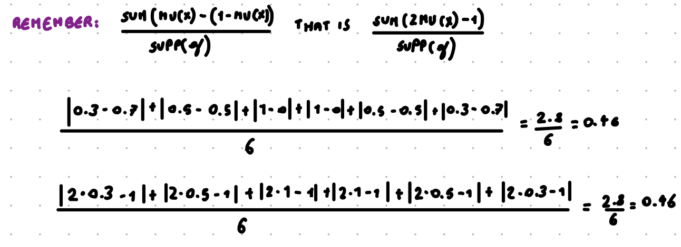
  - Compute the ordered weighted average with wi=1/6
  - Compute the OWA of g with f defined by f(10)=0.7, g(15)=0.4, f(20)= 0, f(25)=1, f(30)=1, f(35)=0.3, f(x) = 0 for all other values of x and w1 = 0.75, w2 = 0.25
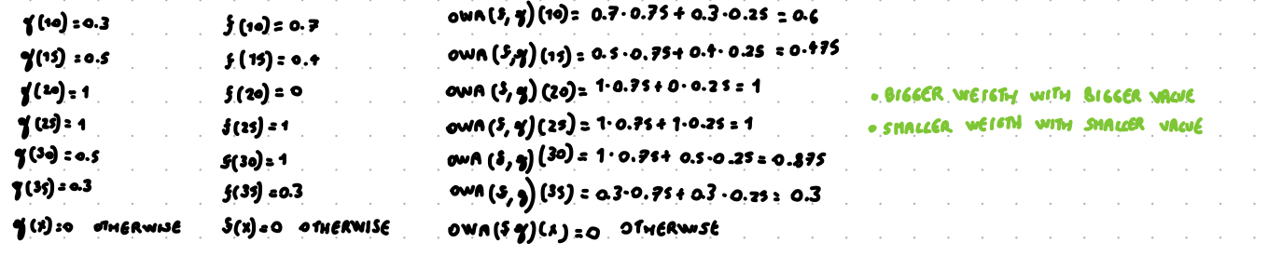
  - Which is a reasonable definition of very(g)? (fix)
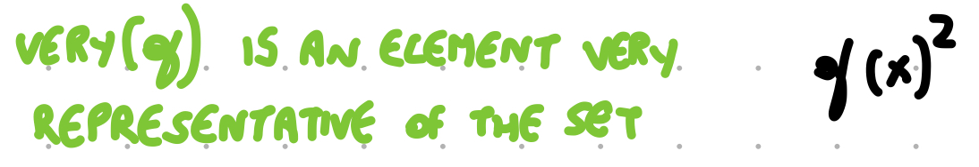
  - Compute the center of gravity of g
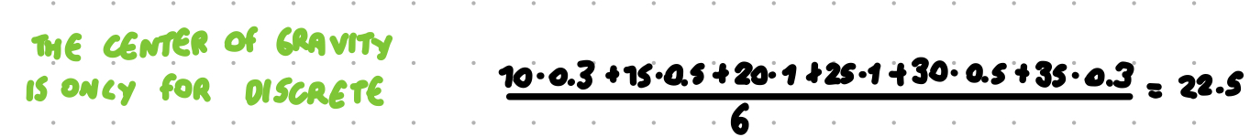

- Given two propositions P and Q, with truth value v(P)=0.7 and v(Q)=0.4, compute
  - The logical and using min, Lukasiewicz and product t-norm
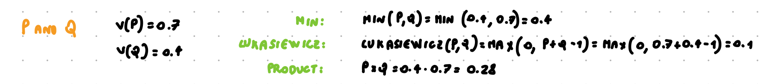
  - The logical or using max, Lukasiewicz and product t-conorm
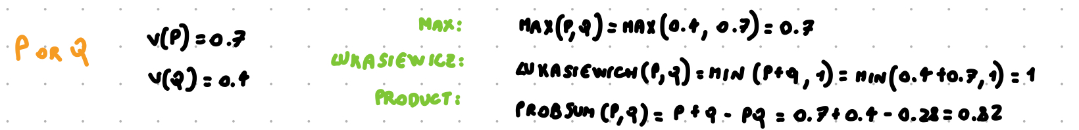
  - P→Q, using an implication at your choice
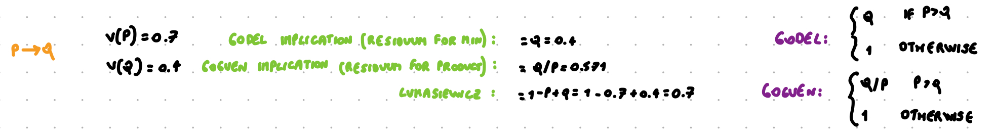
  - The negation of P
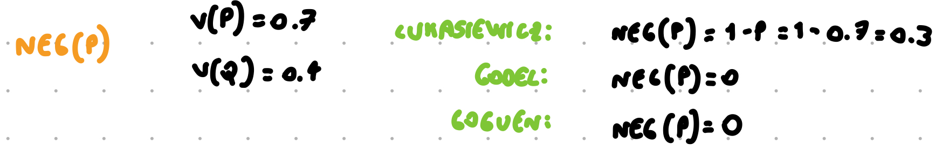
- Exercise on fuzzy clustering
  - Let c1 = (0, 1), c2 = (1,0) and w = 2. Compute the membership of the points x1 = (0.75, 0.5), x2 = (0, 0) and x3 = (0.3, 1.1) to the clusters whose centroids are c1 and c2.
  - Given x1, x2, x3 and the memberships you computed at the previous step, recompute the centroids.

